[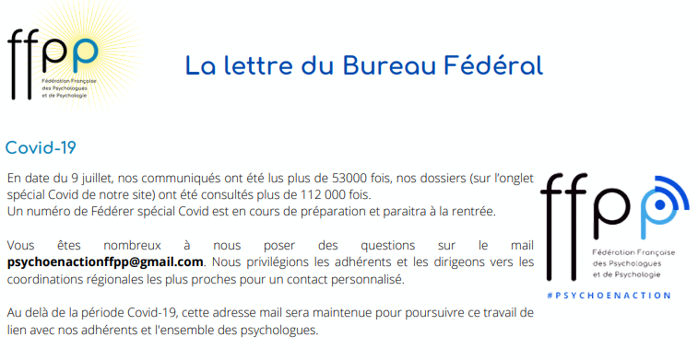](http://www.psychologues-psychologie.net/index.php?option=com_content&view=category&id=106&Itemid=949)

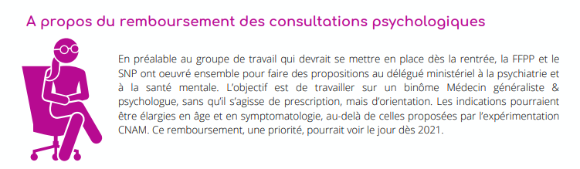

[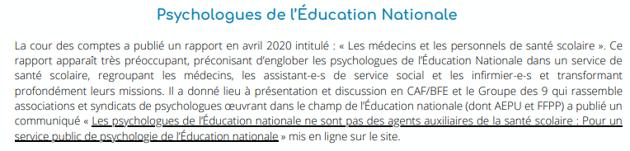](https://psychologues.org/wp-content/uploads/2020/07/CP-du-groupe-des-9-suite-parution-rapport-cour-des-comptes-juin20.pdf)[](https://www.aepu.fr/index.php/component/jdownloads/send/6-aepu-docs/462-communique-aepu-rentree-2020-en-presentiel)

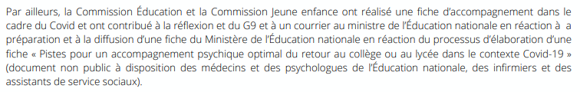

[](http://www.psychologues-psychologie.net/documents/com/2020.06.08.adh/psy.en.pdf?fbclid=IwAR2D067rAe0o0CKmnYx1oSPReeuCP858Z6BvKWmKtqy28596PDHy0vKq2XY)

[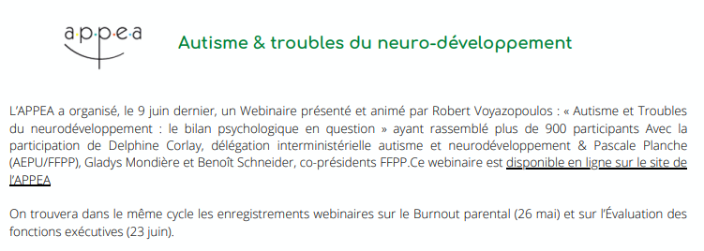](https://appea.org/media/2020/6/replay-du-webinaire-autisme-et-troubles-du-neurode/)

